Myanmar
conservation Newsletter
MYANMAR
Conservation Newsletter

Special Interest Articles:

Greetings
Elephant conservation
Cepf workshop
California Academy of Sciences, Conservation International &
Smithsonian National Zoological Park

Individual Highlights:
ELEPHANTS 2
CEPF & UNU 3
THAMIN 4
BANCA 5

TURTLES 6
OBITUARY 7
LITERATURE 8

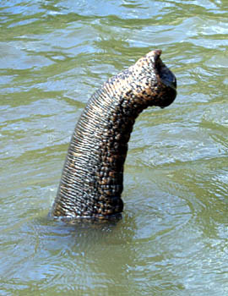
FEBRUARY, 2005
Volume 1, Issue 1
Scientists of the Smithsonian Institution (SI), Conservation International (CI), and California Academy of Sciences (CAS) produced this inaugural newsletter of the MCN to inform interested parties about ongoing conservation activities in Myanmar.
Myanmar, a country rich in natural diversity holds great fascination for biologists and conservationists. It is one of the least known hotspots of biological diversity in Asia. Its biological wealth is a natural legacy of vital importance to the people of the country and the region. Preserving and conserving it will require a concerted effort.
Since the 1990s scientists from a number of institutions and universities have visited Myanmar to explore and study its flora and fauna, to train young Myanmar wildlife biologists and graduate students, and to address some of the country’s many biological conservation needs. The sponsoring organizations represent several countries. The Wildlife Conservation Society (WCS), SI, and CAS have been the main US institutions. The Makino Botanical Gardens and Kyoto University in Japan have supported botanical work. More recently, Birdlife International, the Vienna Natural History Museum, and Conservation International have started projects in Myanmar.
The above-mentioned groups are united in the belief that Myanmar’s environmental challenges are urgent concerns for the welfare of the people and the region. These groups view their work as environmental assistance that should not be delayed. We hope that this newsletter will stimulate interest and lead to increased cooperation and coordination among foreign groups.

GREETINGS

ELEPHANT CONSERVATION
The project Managing two critical ranges of Asian elephants just completed its final year. During the past three years, staff from the Smithsonian’s National Zoological Park and the Ministry of Forestry’s Forest Department collaborated to address elephant conservation in two protected areas. Park staff at Alaungdaw Kathapa National Park (AKNP) and Htamanthi Wildlife Sanctuary (HWS) conducted population surveys at least twice a year. Elephants are elusive and rarely seen in both of these parks. The best way to monitor their presence is by counting dung along transects (paths in the forest).

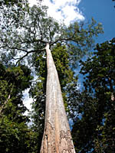
In AKNP there is probably only one herd, and a number of solitary males. There are probably several groups in HWS.
Silver Moon, a cow elephant captured and collared in AKNP in December 2002, transmitted her movement data via satellite for a year and a half. Researchers learned that she used about three quarters of the park in the course of a year, and her home range contracted and expanded seasonally. During the hot dry season her home range was smallest. During the monsoon it reached its maximum size. Curiously, the seasonal differences were far less distinctive during the second year. This is a strong argument for multi-year studies and larger sample sizes of free-ranging elephants. Three more elephants were captured and radio-collared by Myanmar timber enterprise staff in January 2005.
At the end of the project Wemmer facilitated a three day-management planning workshop. Wardens Ye Htut and Myint
Aung, and their key staff members from the two parks generated guidelines and recommendations for the finished document, which was sent to the Department of Forests and the US Fish & Wildlife Service.
The Forest Department, and the National Zoo’s Peter Leimgruber and Chris Wemmer convened a National Elephant Conservation Symposium and Workshop in Yangon in May 2004. During the three-day-workshop a large number of Burmese foresters, wildlife biologists, forest veterinarians, and academicians made present-ations and participated in regional mapping exercises, which will facilitate planning the actual surveys.
This was the first step to initiate the National Elephant Survey, which is being funded by the US Fish & Wildlife Service’s Asian Elephant Conservation Fund.

Tall timber in Alaungdaw Kathapa National Park, near elephant capture site of Dec, 2003

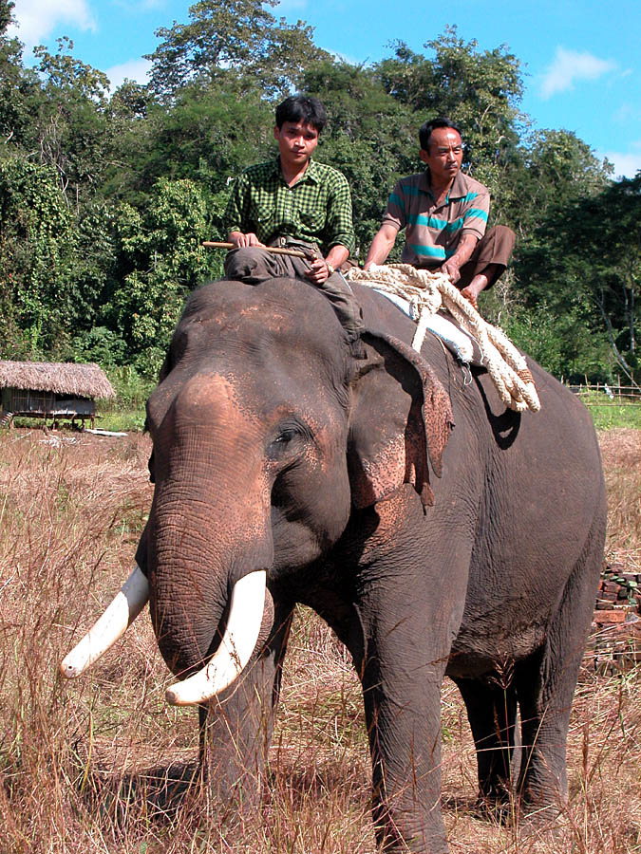
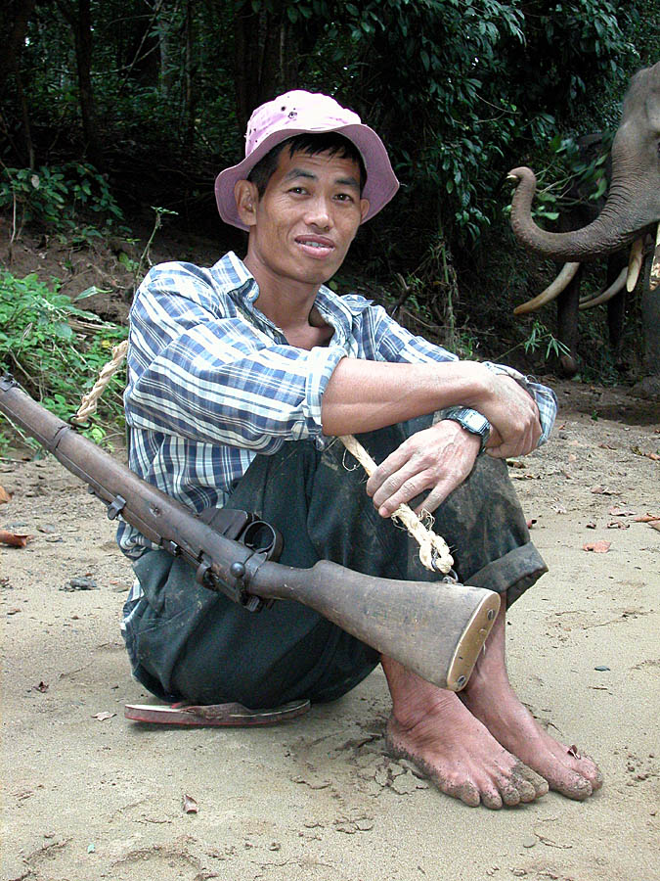

Myanmar Conservation Newsletter Page 2 of 8
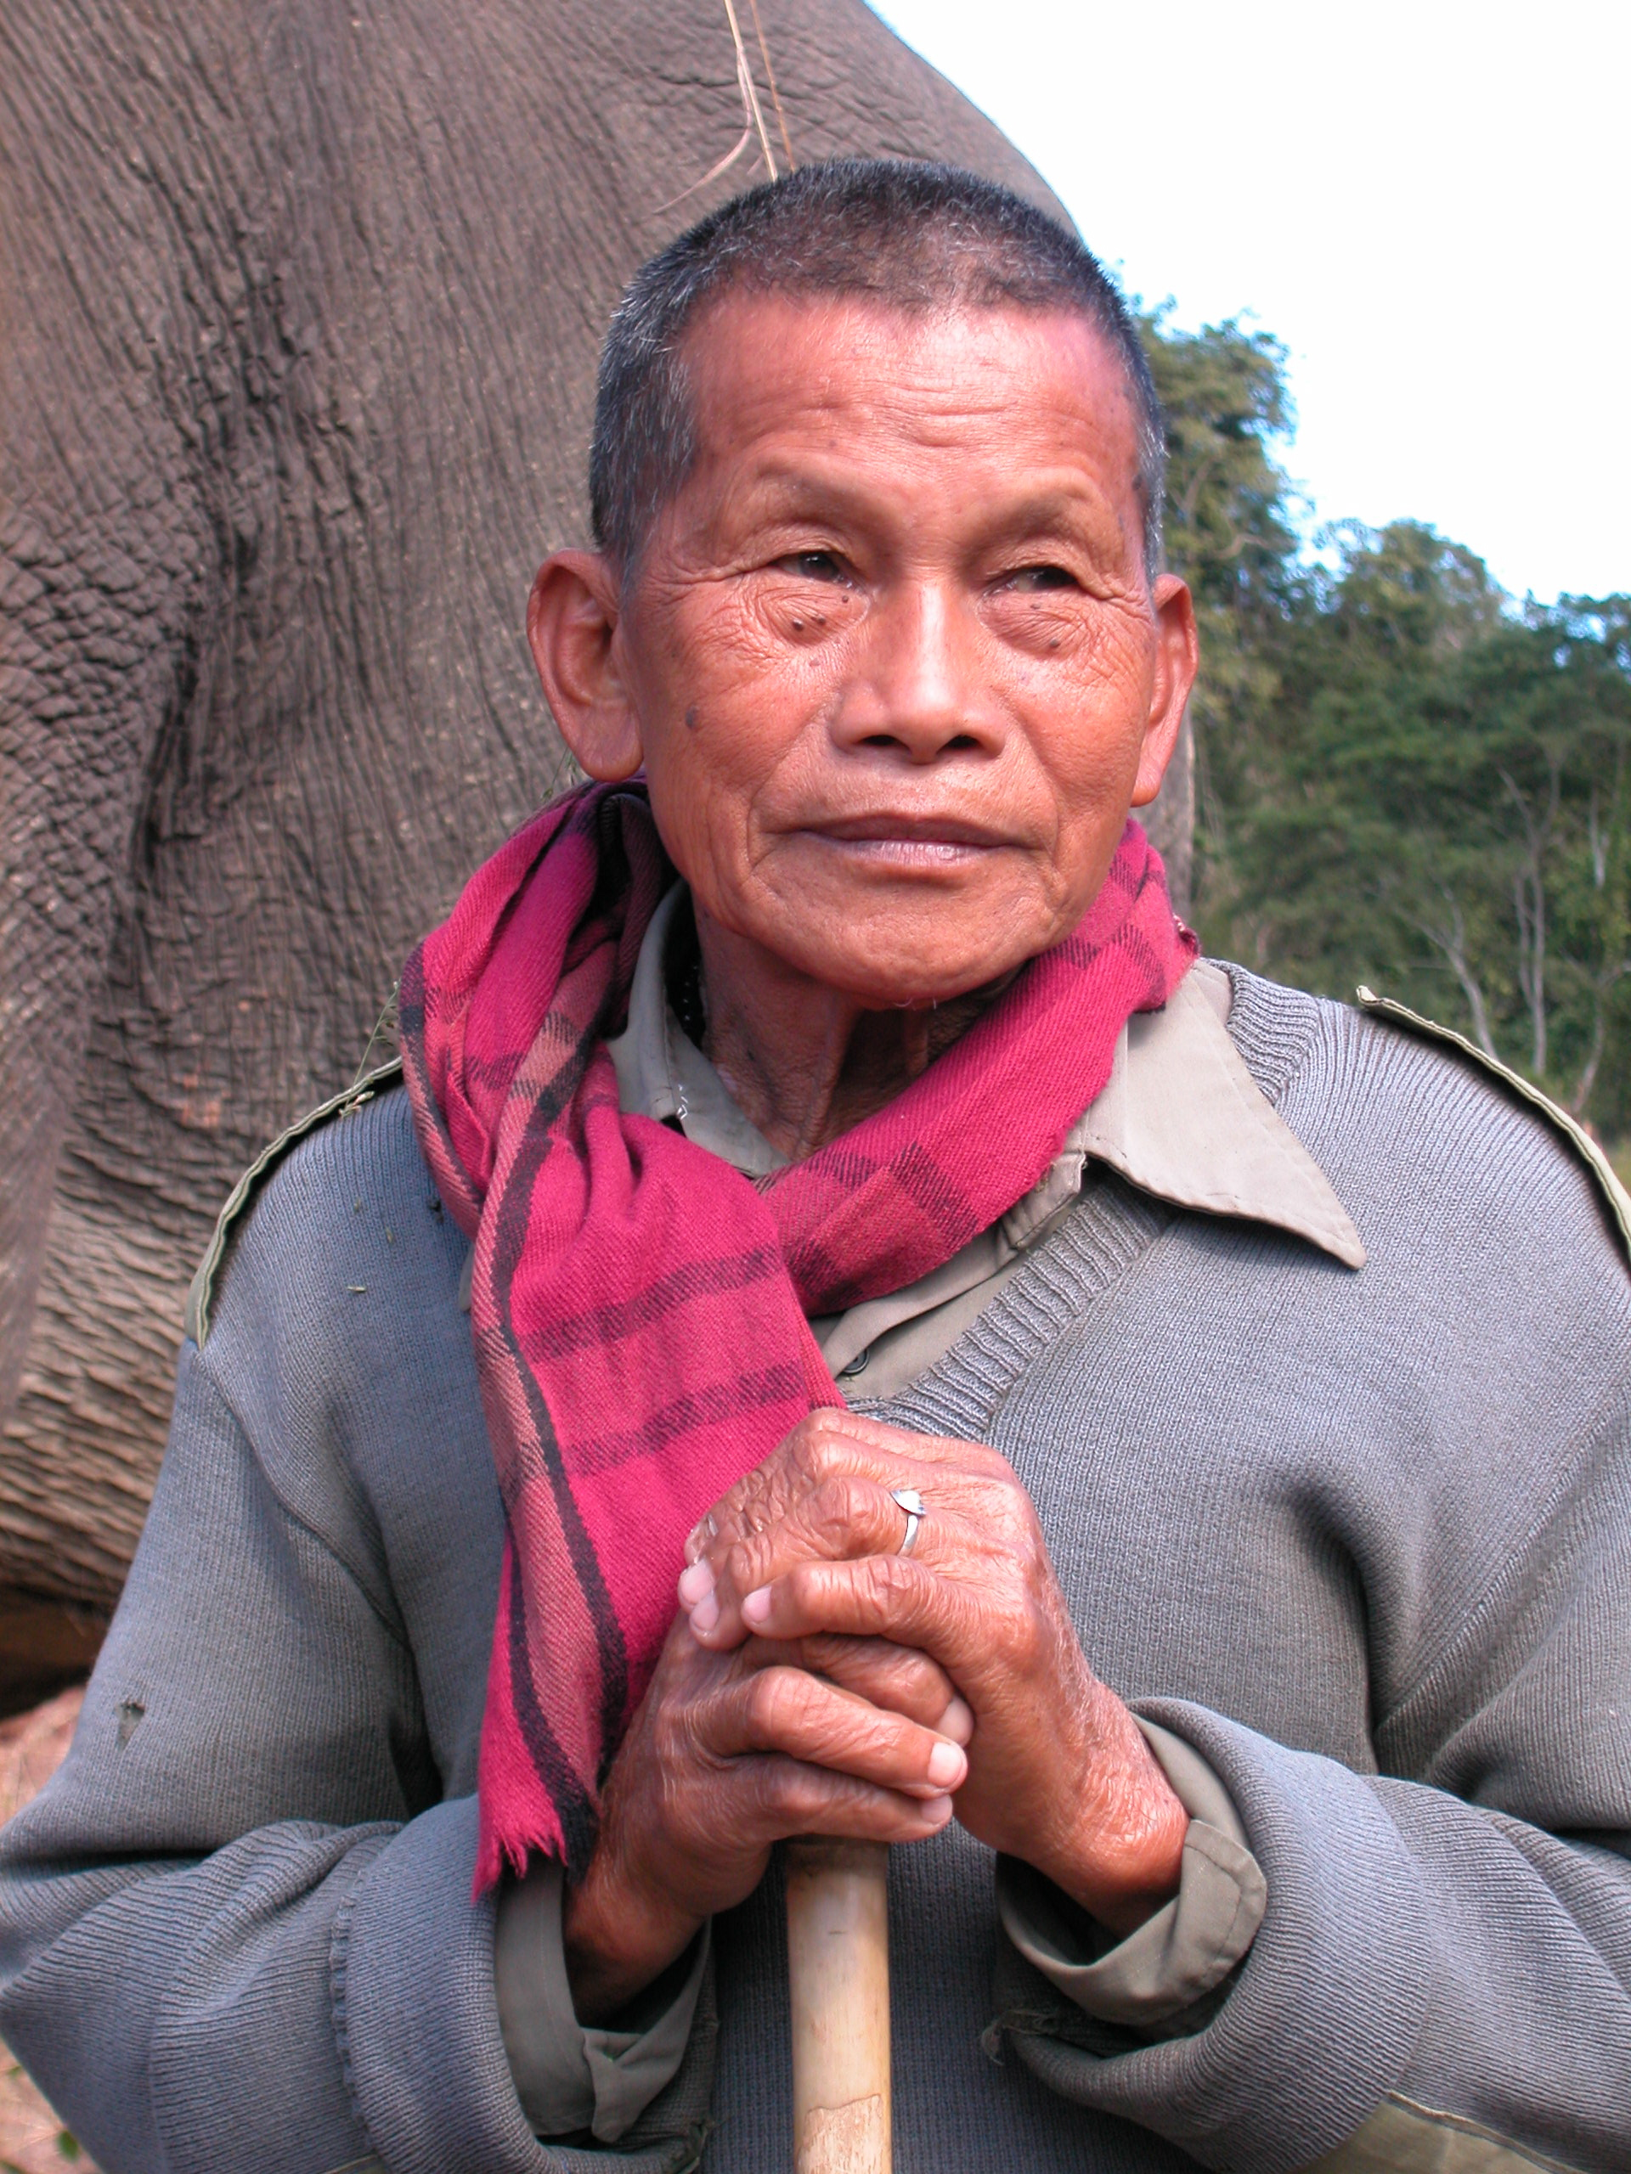
The capture team: Win Tin the elephant tracker (r), and San Nyo “the gunner” with oozie (=mahout) on elephant back (r).
For more about Silver Moon, see the following website: http://nationalzoo.si.edu/
ConservationAndScience/ConservationGIS/projects/asianelephants/trackingsilvermoon.cfm

CEPF WORKSHOP FOCUS ON MYANMAR

The Conservation International (CI) administered Critical Ecosystem Partnership Fund (CEPF) contracted Birdlife International-Indochina to complete a multi-stakeholder assessment of investment opportunities in biodiversity conservation by civil society in Myanmar. Birdlife carried out a similar study for the rest of the Indo-Burma Hotspot shown below. For the Eastern Himalayas portion of the hotspot, the work was led WWF with support from Birdlife. CI’s Center for Applied Biodiversity Science (CABS) provided technical assistance and scientific oversight. For more information on Birdlife, go to birdlifeindochina.cong-ty.com/indexEn.html, on hotspots go to www.biodiversityhotspots.org, and on CABS go to www.biodiversityscience.org.
Preparation of the Myanmar assessment included two workshops in Yangon in August 2003 and July 2004. The report identifies corridors, sites, and species requiring special investment and recommends the following strategic directions: strengthening the conservation of priority sites, mainstreaming biodiversity into other policy sectors, taking focused action on priority species, supporting local civil society to engage in biodiversity conservation, and creating capacity to coordinate conservation investment in Myanmar.
The report will be available in the last quarter of 2004. For more information, contact Jack Tordoff at jack@birdlife.freeserve.co.uk. While Myanmar is not currently eligible for CEPF grant making, it is hoped that this strategy document will stimulate international support for conservation priorities in Myanmar. For more information on the CEPF, go to www.cepf.net.


Dr. Thazin Lwin, Associate Professor in the Chemistry Department at Yangon University, attended the fifth annual International Workshop on the Marine Environment held by the United Nations University (UNU) and the Ocean Research Institute (ORI) of the University of Tokyo. The meeting took place in Otsuchi, Japan, November 2-9, 2004. It focused on coastal and marine ecosystems and advanced technologies that can be used to understand their function. Thazin presented her work with remote sensing specialists on assessing chemical pollutants in the Ayeyarwadi River. Young scientists from Asian and Asia-Pacific nations were invited to apply for travel grants from the UNU. The meeting included discussions and opportunities for exchange of ideas and collaboration.

UNITED NATIONS UNIVERSITY MEETING, JAPAN, 2004

Myanmar Conservation Newsletter Page 3 of 8
Dr. Thazin Lwin, Yangon University chemist

“He regularly ate waterfowl that he poisoned using pesticide-laced fish.”

Sources: Tin Nwe, Si Si Hla Bu, and Hla Hla Win, Preliminary Study of Human Impact on Fish Species Diversity in Kye-In and its Adjoining River System in Chatthin Wildlife Sanctuary, and Shirlee Tan.

CHEMICAL CONTAMINANTS, FRESHWATER LAKES, AND SUSTAINABLE FISHERIES

In 2002, a young fisherman from Kyein village in Chatthin Wildlife Sanctuary died. The cause of death might well have been pesticide poisoning. He regularly ate waterfowl that he poisoned using pesticide-laced fish as bait. Pesticides are unwittingly used to kill fish in SE Asia, and the practice is common in Myanmar.
Biologists and chemists from Yangon University (YU) have joined forces to investigate subsistence fishing and chemical contamination. Their goal is to identify contaminants in the aquatic ecosystem and understand their threat to human health. The site is the 500 ha. Kye-In and adjoining streams in Chatthin Wildlife Sanctuary, which support about 33 species of fish, and is thus an important source of protein in the local economy. The Department of Fisheries have issued permits to fish the wetlands of CWS for several decades’ It is a contentious issue with local fishers because successful bidders have not been residents of the community.
Dr Si Si Hla Bu of the Zoology Department and Dr Thazin Lwin of the Chemistry Department are the advisers of the cross-disciplinary study. Si Si Hla Bu and Ph D student Hla Hla Win have learned that most villagers in Kye-In depend on fish for their livelihood. The village has 70 fishers while the other two villages surveyed, Singaung and Sinma, have less than 15 each. Mean maximum yield ranges from a high of about 7.3 kg/day/fisher in September and October to a minimum yield of 1.8 kg/day/fisher in March and April.
Endosulfan seems to be pesticide of choice. It was found for sale in almost all pesticide shops surveyed. Sellers report that April is the month of peak sales, which coincides with the time of most intensive harvesting. At this time of year water is severely restricted, and large concentrations of fish can be poisoned.
Dr. Thazin Lwin and her student, Moe Kyaw Htet, began to analyze water, sediment, and fish samples in Kye-In and neighboring streams for chemical content and quality. These studies will help define the protocol for a larger survey of contaminants and freshwater fisheries in Myanmar. Co-advisers Shirlee Tan and Chris Wemmer will work with colleagues to draft collaborative grant proposals to investigate contaminants, fisheries and related issues in other parts of Myanmar.

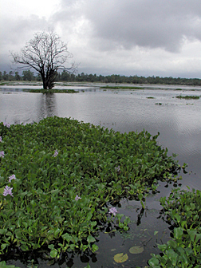
Myanmar Conservation Newsletter Page 4 of 8

Kye-in during the monsoon, 2003. Water hyacinth, an alien species, is overtaking the lake.

H

A Trip to the United States


Miss Khin Ma Ma Thwin (a.k.a. Hazel), an ardent lover of nature who has devoted her life to the conservation of wildlife visited the U.S. as a guest of the International Visitor Leadership Program from July 10 to July 30, 2004. The program was sponsored by Bureau of Educational and Cultural Affairs, Office of International Visitors, Department of State, Washington DC, and is administered by Meridian International Center.
Hazel worked for eighteen years in the Nature and Wildlife Conservation Division in the Ministry of Forestry, where she conducted environmental educational projects and developed materials for them, conducted an annual waterfowl census, collected bird specimens, conducted wetland inventory, and was curator for the Myanmar Biodiversity Museum. She also was Burma compiler for BirdLife International’s Threatened Birds of Asia book. Recently, she and co-author Kyaw Nyunt Lwin published Birds of Myanmar in both English and Myanmar version. Hazel’s father was warden of the Rangoon Zoological Gardens, and she spent her childhood amidst the animals there.
Hazel’s special interest in the organization and management of environmental and conservation NGOs is particularly relevant to her role as secretary of the newly established BANCA (see below). She visited The Nature Conservancy, the Smithsonian’s National Zoo and Natural History Museum, the Wildlife Conservation Society, and the California Academy of Sciences, as well as Yellowstone, Yosemite, and Shenandoah National Parks. Hazel said of the sojourn, “This was a lifetime experience, and can’t wait to apply some of the lessons I learned.”

Hazel birding in Montana last summer.

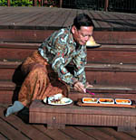
“BANCA is one of the rarest of birds, a truly indigenous environ-mental NGO in Myanmar,” says U Uga.

A new conservation NGO, the Biodiversity and Nature Conservation Association, or BANCA, was officially recognized by the Home Ministry, 26 May 2004. U Uga initiated the organization and serves as honorary chairman. A wildlife biologist who retired from 36 years of service in the Forest Department, he says, “BANCA is one of the rarest of birds, an truly indigenous environmental NGO in Myanmar. Its mission is conservation of
Nature and biological diversity through actions based on research,
advocacy, network-building, partnership, education and public
awareness.”
BANCA has a board of six directors, and a membership of 61, and is currently administering four projects. BANCA’s application for a tax-exempt bank account hopefully will be granted in 2005.
Birdlife International funds the rental of BANCA’s office, and one staff member. U Uga serves as BANCA’s honorary Chairman. Khin Ma Ma Thwin, who has been supported by contracts to participate in Birdlife International’s expeditions, is BANCA’s honorary Secretary. Birdlife International was an early supporter of the BANCA office, and has worked closely with the small staff and volunteers to conduct surveys for the extremely rare Guerney’s pitta, in the lowland forests of Tanintharyi Division. At the moment, BirdLife International is is supporting BANCA’s Mission by launching site support group activities in two villages in southern Chin State, which.

BANCA Launched

Myanmar Conservation Newsletter Page 5 of 8

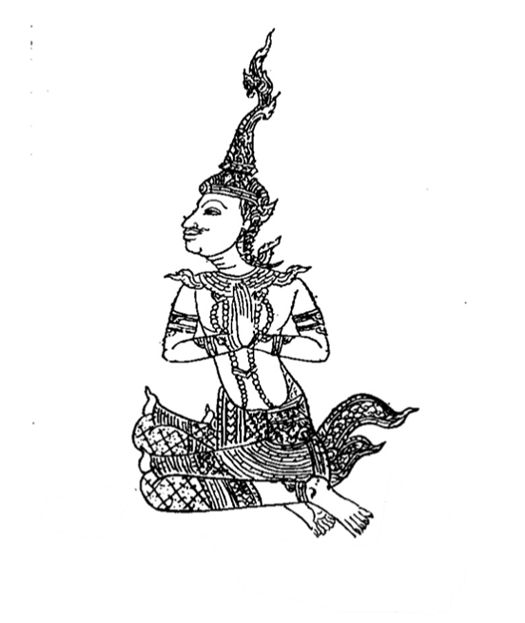

Collaborative Turtle Research at Mandalay University (Source: Gerald Kuchling)

The Zoology Department of the University of Mandalay conducts research programs on five endemic turtles of Myanmar in collaboration with Gerald Kuchling, School of Animal Biology, The University of Western Australia. In February 2004 Mandalay University granted a PhD to Thanda Swe for her thesis “Autecology of Myanmar Star Tortoise, Geochelone platynota”, with G. Kuchling as External Examiner. In January/February 2004 four postgraduate students participated in a WCS-funded collaborative river turtle survey (with G. Kuchling, WCS-Myanmar, and the Nature and Wildlife Conservation Division of the Forestry Department) which identified two remnant populations of K. trivittata in the upper Chindwin and Dokhtawady rivers. Six research students enrolled as PhD candidates at Mandalay University in 2004 to work with Kachuga trivittata and/or other river turtles including Nilssonia formosa and Chitra vandijki, the tortoise Geochelone platynota and with turtles in pagoda ponds. They presented their project proposals and preliminary results to an audience of professors and lecturers of various Myanmar Universities, Gerald Kuchling, Jake Brunner and David Emmett (CI), and Doug Hendrie (WCS Asian Turtle Coordinator) at a seminar at Mandalay University on 30 November 2004, together with several master students working on the ecology of other turtles, including the endemic Lissemys scutata.

The Nat of the serpents and related creatures

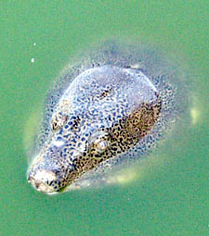

Myanmar’s Turtles and Tortoises

Myanmar’s proximity to China places its turtles and tortoises at high risk of extinction. The illegal trade in turtles is a dire threat.
“A massive harvest of freshwater turtles and tortoises is currently occurring throughout Southeast Asia in response to growing demands from markets in southern China.” So reads the WCS’s report of March 2003 (see page 8 for full reference). Author John Behler and his co-workers state, “It has been conservatively estimated that over twelve million turtles pass through these markets each year.”
Myanmar, with its extensive river systems and diverse habitats is home to a large number of turtles and tortoises, and many of them are endemic. Three of the world’s top 25 most endangered turtles and tortoises (Arakan forest turtle Heosemys dypressa, Burmese star tortoise Geochelone platynota, and Burmese roofed turtle Kachunga trivittata) are endemic to Myanmar according to an assessment by the Turtle Conservation Fund—a partnership of CI’s Center for Applied Biodiversity Science, The World Conservation Union Species Survival Commission’s Tortoise and Freshwater Turtle Specialist Group, and IUCN/SSC Turtle Survival Alliance (TSA). For more information, go to www.conservation.org.

Myanmar Conservation Newsletter Page 6 of 8
r

Obituary: Htun Win, 1973 - 2004

Htun Win, a friend and young colleague of scientists from the California Academy of Sciences and Smithsonian, died of pneumonia on June 11, 2004.
Htun Win was the second son of U Win Shwe and Daw Pyone of Wuntho, Sagaing Division. He was the team leader of the national reptile and amphibian survey team at the time of his death. His energy in the field and enthusiasm for herpetology were characteristics much appreciated by his colleagues and visiting scientists.
Htun Win’s first encounter with natural history studies was in 1996 when he attended the SI’s Mammal Inventory Course at Chatthin Wildlife Sanctuary (CWS). At the time, he was working as a forester in CWS and was also pursuing undergraduate correspondence studies in Geography. NMNH mammalogist, Don Wilson commented that “Htun Win was first one up in the morning and the last one to turn in.” He followed the instructors, and noted various bits of information in a small notebook. At the time, his command of English was limited, but he was eager to learn, and was constantly looking up words in his pocket dictionary. Htun Win’s energy and curiosity impressed Don. Don was also convinced that Htun Win owned only one black t-shirt that he wore daily during the course. As a parting gift he gave him an American Society of mammalogists t-shirt.
The following year, Htun Win took George Zug’s reptile and amphibian course in CWS and discovered his love of herpetology. Not long afterwards, Joe Slowinski and George hired him as the leader of the national survey team. They also hired Ma Thin Thin, who was also an avid student, but whose gift for seeing cryptic creatures is uncanny. The two were married early in 2004.
Htun Win had found his niche, and threw himself into his work. His English improved. He mastered common and scientific names of Myanmar’s reptiles and amphibians, and became a “walking encyclopedia” on Myanmar’s herpetology. In Yangon, he worked late at night pouring over records, making lists and sending e-mail messages to his co-workers in the states.
Htun Win’s short career as a herpetologist was extremely productive, and his service to the national survey was truly outstanding. His premature passing is a great loss to his wife, family, and colleagues.

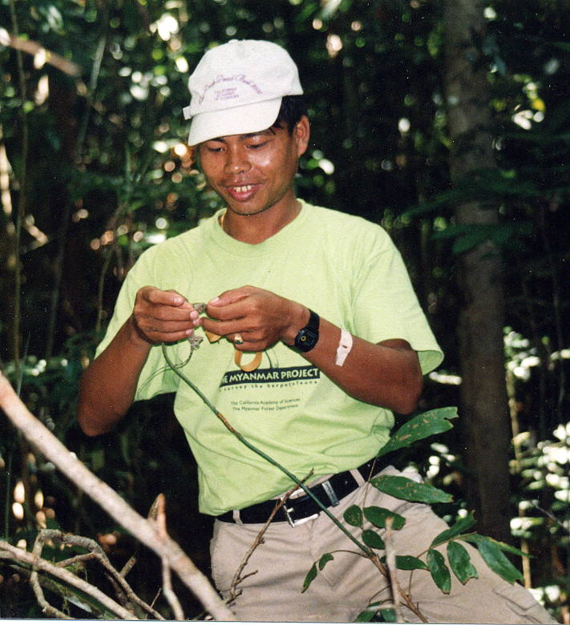

Myanmar Conservation Newsletter Page 7 of 8
Htun Win at home in the field collecting reptiles and amphibians for the national herp survey

California academy of sciences,

Conservation International

& Smithsonian National Zoological

Park
Aung, Myint, Khing Khaing Swe, Thida Oo, Kyaw Kyaw Moe, Peter Leimgruber, Teri Allendorf, Chris Duncan, and Chris Wemmer. 2004. The environmental history of Chatthin Wildlife Sanctuary, a protected area in Myanmar (Burma). Journal of Environmental Management, 72:205-216.

Behler, J.L., W. Holmstrom, J. Thorbjarnarson, and Saw Tun Khaing. 2003. Conservation of Freshwater turtles and tortoises in Myanmar. Wildlife Conservation Society, 18 pp.

Eberhardt, K. 2003. Report of assessment for integrated conservation and development project, Alaungdaw Katahap National Park, and Htamanthi Wildlife Sanctuary. CARE Myanmar, 31 pp, plus appendices

Hla, Tin, Sein Myo Aung, Saw Moses, Jonathan Eames, and Saw Nyunt Tin. 2003. Guerney’s pitta survey and biodiversity conservation assessment in Tanintharyi Division, Myanmar. 21 pp.

Kress, W. J., R. A.DeFilipps, E. Farr, Daw Yin Yin Kyi. 2003. A Checklist of the Trees, Shrubs, Herbs, and Climbers of Myanmar. Smithsonian Institution Contributions from the United States Herbarium 45:1-590.

Kress, W. J., Thet Htun. 2003. A Second Species of Smithatris (Zingiberaceae) from Myanmar. Novon 13: 68-71.

Kyi, Sai Wunna and G.R. Zug. 2003. Unusual foraging behavior of Naja kaouthia at the Moyingye Wetlands Bird Sanctuary, Myanmar. Hamadryad, 27(2):265-6.

Leimgruber, P., D.S. Kelly, M. Steininger, J. Brunner, T. Mueller, and M. Songer. 2003. Forest cover change patterns in Myanmar 1990-2000. Report to Conservation International and the United States Fish & Wildlife Service.

Leimgruber, P.,J.B. Gagnon, C. Wemmer, D.S. Kelly, M.A. Songer, & E.R. Selig. 2003. Fragmentation of Asia'a remaining wildlands: implications for Asian elephant conservation. Animal Conservation 6:347-359.

Leviton, A., J. Vindum, M. Koo, R. Lucas, G. Wogan. 2003. Dangerously Venomous Snakes of Myanmar. Illustrated Checklist with Keys. California Academy of Sciences, San Francisco. 81 pp.

Lynam, A.J. 2003. A National Tiger Action Plan for the Union of Myanmar. Myanmar Forest Department and Widllfie Conservation Society, International Program, 57 pp.

Rabinowitz, A. 2004. A Question of balance, how tigers, gold miners, and gun-toting revolutionaries are competying to survive in Myanmar’s “Valley of Death”. National Geographic Magazine, 205(4):98-117.

Vindum, J., H. Win, T. Thin, K.S. Lwin, A.K. Shein, & H. Tun. 2003. A new Calotes (Reptilia: Squamata: Agamidae) from the Indo-Burman Range of western Myanmar. Proceedings of the California Academy of Sciences, 54: 1-16.

Wilkinson, J., H. Win, T. Thin, K.S. Lwin, A.K. Shein, & H. Tun. 2003. A new species of Chirixalus (Anura: Rhacophoridae) from western Myanmar (Burma). Proceedings of the California Academy of Sciences, 52: 17-26.

Williams, K. J., W. J. Kress, Thet Htun. 2003. A Striking New Epiphytic Hedychium (Zingiberaceae) from Myanmar with a Discussion on Some Anomalous Related Genera. Edinburgh Journal of Botany, 60 (1): 43-48.

Wogan, G. H. Win, T. Thin, K.S. Lwin, A.K. Shein, S.W. Kyi, & H. Tun. 2003. A new species of Bufo (Anura: Bufonidae) from Myanmar, and redescription of the little-known species Bufo stuarti Smith 1929. Proceedings of the California Academy of Sciences, 54: 141-153.

Recent publications and reports, 2003--2004

The article on the environmental history of Chatthin Wildlife Sanctuary by Myint Aung and colleagues (cited above) was highlighted in the September issue of Frontiers in Ecology (2004). An informative commentary can be found at http://www.lesliebienen.com/publications.htm

Join us by Contributing to the newsletter…
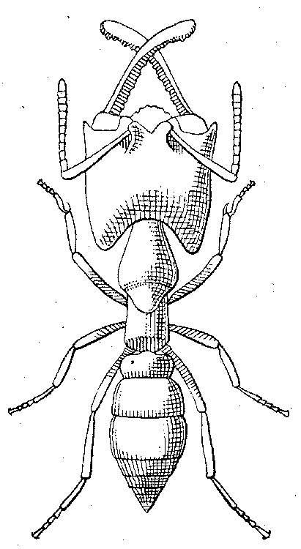

We are an informal group of conservation biologists dedicated to training, education, research and conservation initiatives for the long-term preservation of Myanmar’s natural landscapes and biodiversity. If you have information to share with the readership about ongoing or planned environmental work in Myanmar, please submit word files and jpgs for inclusion in the next issue.
Send material to Chindwin@sbcglobal.net

